BIOLOGY FOR COMPUTER ENGINEERS- BBOC407

MODULE 1

Module 1
CELL BASIC UNIT OF LIFE

Introduction. Structure and functions of a cell. Stem cells and their application.

Biomolecules: Properties and functions of Carbohydrates, Nucleic acids, proteins, lipids.

Importance of special biomolecules: Properties and functions of enzymes, vitamins and hormones.

https://nptel.ac.in/courses/121106008

Introduction

WHY BIOLOGY ?

- … offering interdisciplinary perspectives and potential applications in areas such as bioinformatics, computational biology and medical technology.

- It enhances the student's ability to integrate biological concepts into computer science advancements.

- It is well known that this is the century of biology in which significant advances in the understanding and application of biological systems are expected.
- The significant impact on the world is expected in terms of better healthcare, better processes, better products and an overall better quality of life.
- Thus, any person can be interested in knowing the fundamentals of biology to be able to understand, or participate in the biological revolution.
- For example, any engineer, irrespective of the parent discipline (mechanical, electrical, civil, chemical, metallurgical, etc.,) has a high probability of using the disciplinary skills toward designing/improving biological systems in the future.

CELL:

- It is the fundamental unit of life.
- It represents the smallest structural and functional entity of a living organism.

CELL FORMATION:

Life originated from creation of cells, their complexity and organization. So the process and formation of cell can be categorized as FOLLOWING:

- Prokaryotic : they lack a true nucleus. Ex- BACTERIA

- Eukaryotic : they have a true nucleus and membranes surround the organs inside the cell. Ex- FOUND IN PLANTS ANIMALS, FUNGI.

Summarizing: Cell formation is the first stage of life., with nucleus and other organelle’s.

CELL DIVISION:

- Cells have the ability to divide (multiply), through the process of mitosis (eukaryotic) or meiosis.

- This division is very essential for growth, development and maintenance of living organisms.

MULTICELLULARITY:

- Over time, cells multiply, and give rise to multicellular structure.

- They further form specialized cell types, which will have distinctive function

- They also give rise to tissues, organs, and organ systems.

DIFFERENTIATION :

- Cells within Multicellular organisms undergo a differentiation process.

- i.e., they undergo their own special changes to acquire special structure based on their own requirements, functions and environmental conditions .

- This enables the cells to perform specific tasks within the organism.

ORGANISM FORMATION :

- Combination of specialized cells or tissues or multicellular structure or organs, results in the formation of a complete organism.

- Organisms can range from simple to complex

- Organisms emerged based on organization and coordination of cells.

REPRODUCTION :

- Organisms reproduce to pass their genetic information like memory, physical characteristics and other features.

- Types of reproduction: sexual/asexual.

ADAPTATION AND EVOLUTION :

- Over generations living organisms undergo adaptation and evolution.

- New species of animals or animal kingdom may evolve based on requirements or environmental conditions.

- Genetic material within the cell can change through mutation and based on natural selection leading to development of diverse species.

ECOLOGICAL INTERACTIONS :

- Organisms interact with the environment and with each other in a complex ecosystem.

- These interactions contribute to the balance of life and sustainability of the ecosystem.

Introduction to Cell Structure

- Cells are the basic units of life …They are Classified as prokaryotic and eukaryotic cells (membrane bound cells).

- Cell Components

• Cell Membrane : It surrounds the cell.
It regulates entry and exit of any substance.
It is semi permeable, water and air can pass through it.
It acts as a protective cover.

• Nucleus (present in Eukaryotic Cells) : It contains genetic material like DNA.
Its known as “brain” of a cell since it controls all activities of the cell.

• Cytoplasm : It is a gel-like substance present inside the cell membrane.
It has organelles and it helps them to float and also holds them.

• Organelles : They are specialized structure, with specific functions
Example- Mitochondria produces energy in a cell.

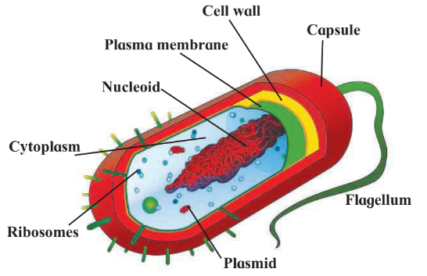
Fig 1. Schematic of A Prokaryotic Cell

- As in figure 1, cells do not have well defined nucleus but only nucleoid is present, and look like bacteria with long tails and shape.
- Cytoplasm , Cell wall and cell membrane present.
- Capsule like Nucleoid are present.
- Organelles like Plasmid, Ribosomes are present.

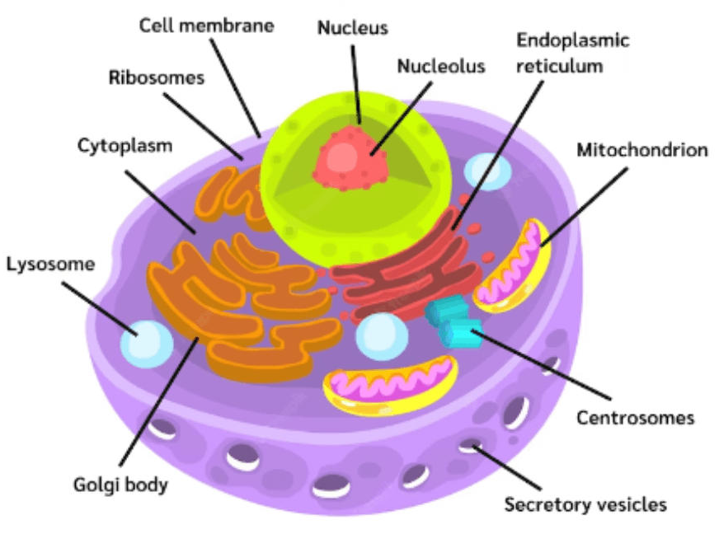

Fig 2. Schematic of A Eukaryotic Cell

- As shown in figure 2, cells have a well defined nucleus and have complex structure.
- It's slightly oval in shape.
- It has Ribosomes, Endoplasmic reticulum, Mitochondrion, Centrosomes, Golgi body, Lysosome.

Functions of a cell.

- Cellular Respiration :

- Means generation of energy.
- The Mitochondria generates energy in the form of Adenosine Triphosphate (ATP), through cellular respiration.
- It is a process of producing energy by cell.

- Photosynthesis (in Plant Cells) :

- Process of generating food by cells present in plant leaves.
- Plants absorb water from soil using roots, which gets transferred to leaves.
- Leaves contain specialized cells called CHLOROPLAST that convert sunlight into glucose.

- DNA Replication and Cell Division :

- The Nucleus (Eukaryotic) having DNA has this process.
- DNA produces a single strand that will grow into a double strand and replicates it.
- Replication and division of cells is controlled by cells for the purpose of growth in animals.

- Protein Synthesis :

- Ribosomes synthesize proteins using the feed (genetic information) given by the nucleus.
- Proteins are generated in cells and are very essential for any animal.
- Type of protein to be generated in a cell is decided by genetic information or DNA.
- Based on requirement proteins are synthesized or supplied.

STEM CELLS and their Application
.

Introduction to Stem Cell

- Stem cells are unique cells.
- They have the ability to develop into various specialized cell types (cells in heart, kidney, eyes are all different)…
- They play a very crucial role in growth, mainly tissue repair.

Types

- Embryonic Stem Cells

- These are derived from embryos.
- They have the potential to become any body cells and forms.
- For example, these cells can become heart cells and tissues or they can become kidney cells and so on.
- After fertilization, within 3 days the healthy embryo is formed and it will contain upto 6 to 10 embryo cells as in figure 3.

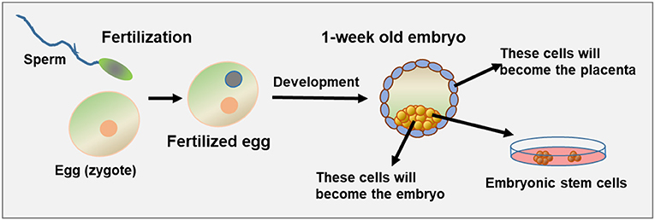
Figure 3. Embryonic Stem Cells

- Within a week a fertilized egg is formed and it's called Blastocyst.
- From embryo, cells are separated and stored, for research purposes.

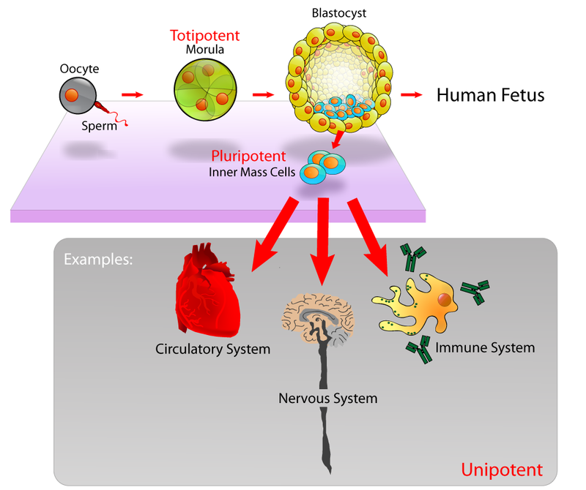
Figure 4. Examples of Embryonic Stem Cells

- Adult or Somatic Stem Cells

- These cells are found in various tissues.
- These cells are obtained from specialized organelles and are adult/ grown up cells.
- If cells are taken from the brain, then they become Brain Somatic stem cells, if taken from heart, they become heart somatic stem cells.
- Each cell performs their particular role.
- They can be used to replace damaged cells in organs accordingly.

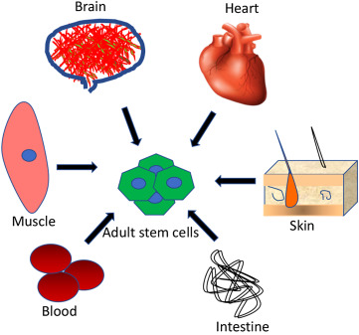
Figure 5. Somatic Stem Cells
Applications

- Regenerative Medicine : Stem cells are used to regenerate damaged tissues & organs.
- Tissue Repair
- Orthopedic Treatments : Joint and bone regeneration

- Treatment of Diseases
- Blood Disorders : treating Anaemia, leukemia by replacing blood cells.
- Neurological Disorders : In Parkinson and Alzheimer diseases.

- Drug Development and Testing : For testing new drugs before using them on animals.

- Understanding Disease Mechanisms : In labs and controlled manner, diseases and their spread and control, can be studied using stem cells.

- Cell-Based Therapies : To address various medical conditions and treating a particular malignant cell to stop spreading of disease.

- Personalized Medicine : Tailoring treatments based on personalized traits and genetics and characteristics.

Challenges

- Controlling Cell Differentiation : ensure precise control of differentiation of stem cells into specific stem cells.

- Genetic Stability : Maintaining stability during their growth, so that mutation / abnormalities do not happen.

- Tumor Formation : Potential of stem cells to form tumors to be addressed.

- Immunological Rejection : In some treatments body may not accept stem cells injected in / may be bio incompatible, this called immunology rejection.

Ethical Considerations

- Source of Stem Cells :

- The concern here is in using the embryonic cell. It involves disturbing the embryo.
- There are many debates happening on the sanctity of human life.
- The challenge here is, in balancing, scientific progress with ethical concerns.

- Informed Consent :

- The source of the embryo is a concern as it is only a few cells.
- Bio technologist has to take consent before taking the Stem cells for research and treatment

- Global Regulations :

- There are different rules and regulations in different countries.
- Universal guidelines are required in this area of study.

- Commercialization and Access :
- Making the therapy as a business, affordability becomes a major challenge for the general population.
- It is a concern, so the government should ensure fairness here.

Biomolecules:

Introduction to Biomolecules:

- Biomolecules are the building blocks of life.
- They play very crucial roles in the structure and functioning of living organisms.

Key Bio molecules are as follows:

- Carbohydrates :

- They play a very crucial role as fuel supply, supporting growth and facilitating energy release.

- Nucleic Acids :

- They are fundamentals for inheritance, animal character, nature, behaviour, and are similar to their ancestors.
- These are responsible for Good/Bad things and genetic diversity.
- DNA & RNA are used to synthesize proteins that are essential for the life process.

- Proteins :

- They Contribute to regulation of biological processes forming the cellular structure.
- They catalyse many chemical reactions happening in our body, for growth and other purposes.
- They speed up biological reactions.

- Lipids :

- These are needed for maintaining cell integrity / shape.
- Provide protective barrier acting as a membrane
- Serve as a reserve energy source.

CARBOHYDRATES

- These are classes of organic compounds.

- They play a crucial role in biology and are important energy sources.

- They are composed of carbon (C), hydrogen (H), and oxygen (O) atoms and are classified based on their molecular structure and function.

- General formula is C_{n}(H₂O)_{n}

- Simple Carbohydrates obey this formula whereas complex carbohydrates do not obey this formula.

- They are classified as follows:
- Monosaccharides
- Disaccharides
- Polysaccharides

Monosaccharides :

- Simple form of Carbohydrates and are water soluble.

- Having a single structure and serve as the primary source of energy.

- Carbon having double bond with Oxygen or with single bond

- Example: - Glucose, Fructose.

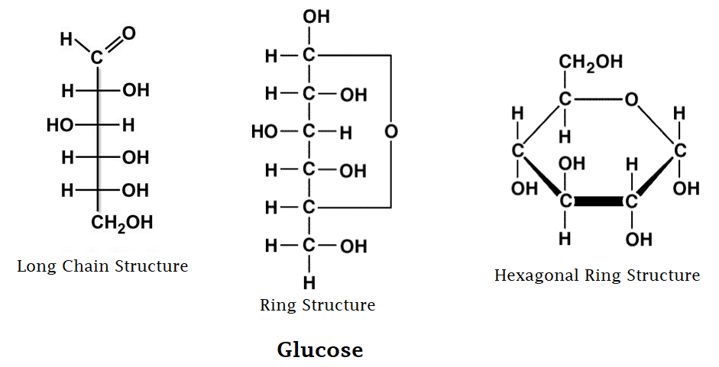
Figure 6. Glucose
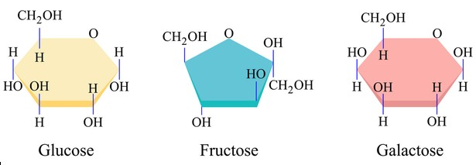
Figure 7. Glucose, Fructose & Galactose

Disaccharides :

- Two monosaccharides combined becomes Disaccharides

- They are formed by condensation of 2 monosaccharides

- They are commonly found in Sugar and broken down into monosaccharides.

- Example: Sucrose, Lactose, Maltose

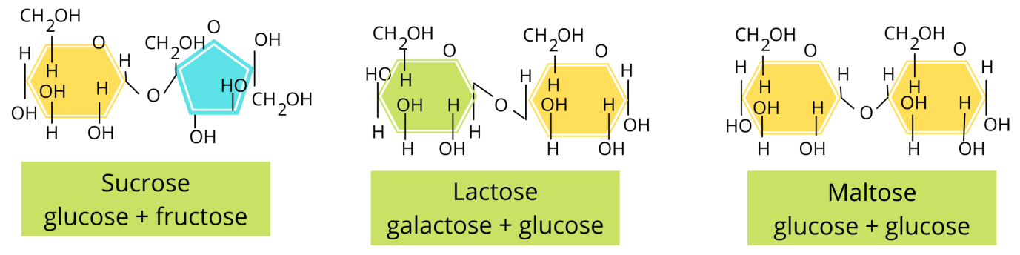
Figure 8. Sucrose, Lactose & Maltose

Polysaccharides :

- Poly means “many”.

- Many such saccharides are combined.

- These are long chain monosaccharides that are linked together.

- Storage molecules of energy.

- Example: Glycogen in animals, Starch in plants.

- Cellulose in plants play an important role as cellular processors i.e, cellular processes [ signaling, recognition ( identifying things ), and in reflecting gene expressions ]

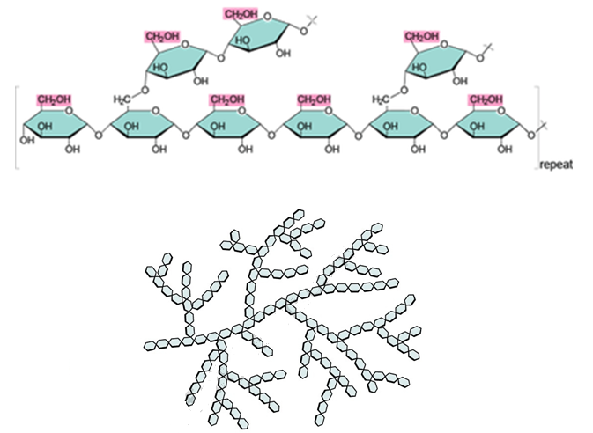
Figure 9. Glycogen
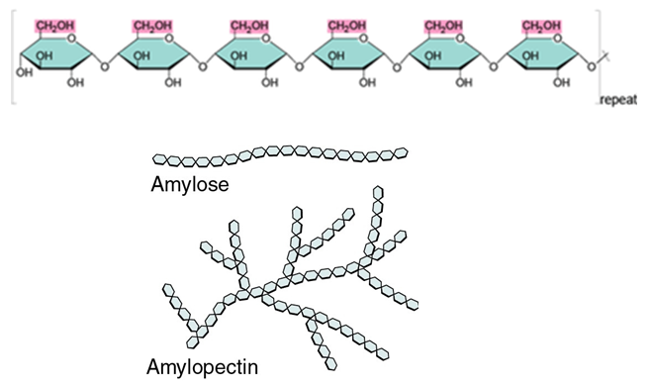
Figure 10. Starch

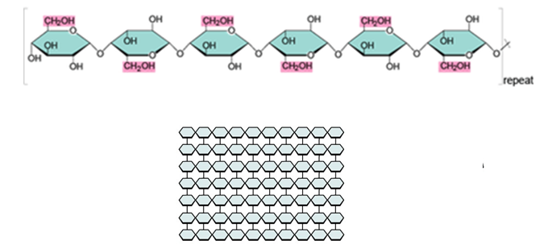

Figure 11. Cellulose

NUCLEIC ACIDS:

- They are long chain biological polymers.
- Same Molecules are repeated many times in sequence.
- It is used for storage and transfer of genetic information.
- Artificial Nucleic Acids are also synthesized now-a-days.

- Types: DeoxyRibonucleic Acid (DNA) and Ribonucleic Acid (RNA).
- Both are used for processes like replication, Transcription , Translation of genetic information.

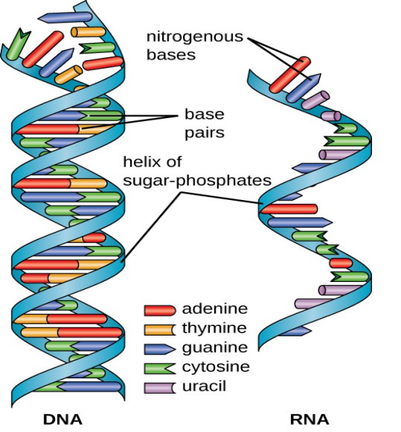
Figure 12. DNA and RNA Schematic representation.
DNA:
- DNA information is for development, functioning and for reproduction.
- It is actually a double stranded helical structure.
- It consists of sugar molecules, phosphates, and Nitrogen bases like Adenine, Guanine, Cytosine and Thymine.

RNA:

- It involves expression of genetic information stored in DNA by carrying the message from DNA to RNA.
- Used to duplicate the genetic information by separating 1 strand from DNA, and this strand is called messenger RNA(mRNA).
- mRNA carries the information of various nucleotides and their sequence.
- The mRNA becomes a copy of DNA, and is used to build/ produce proteins.
- It acts as a base structure, to act and combine, with amino acids, to produce protein, based on requirement.

PROTEINS

- Proteins are large, complex molecules made up of chains of smaller building blocks called amino acids.
- Proteins play a vital role in forming structure.
- Each protein is formed by different amino acids.
- There are totally 20 amino acids, out of which 9 are essential and 11 are non essential amino acids.
My Intuition
Essential Amino Acids (9):

- Essential for the body and has to be taken through diet/ or supply through food.

- Histidine
- Isoleucine
- Leucine
- Lysine
- Methionine
- Phenylalanine
- Threonine
- Tryptophan
- Valine

Non-Essential Amino Acids (11):

- Essential for the body and generated/ synthesized in the body whenever required.

- Alanine
- Arginine
- Asparagine
- Aspartic Acid
- Cysteine
- Glutamic Acid
- Glutamine
- Glycine
- Proline
- Serine
- Tyrosine

LIPIDS

- Lipids are a group of organic compounds that include fats, oils, waxes, and some hormones.
- They form membrane structure.
- Our body has 70% water.
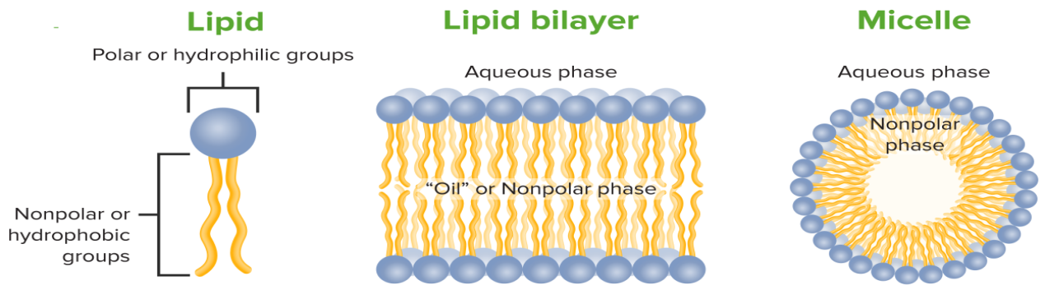
Figure 13. Lipids

- Head of Lipid has interaction with water molecules whereas tail does not..
- Non Polar come together to form a spherical or other structure as seen in figure 13.

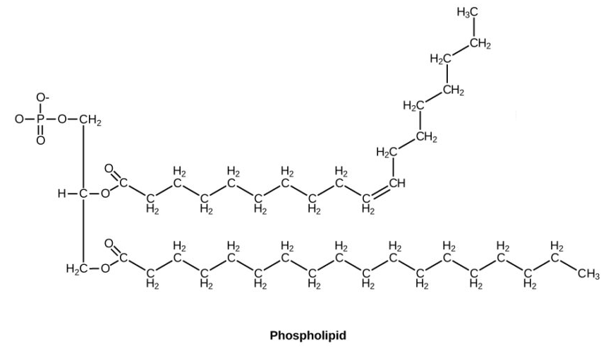
Figure 14. Phospholipid (head)

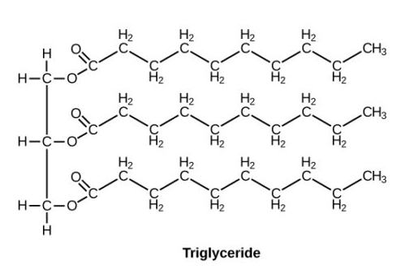
Figure 15. Triglyceride (tail)

PROPERTIES AND FUNCTIONS OF CARBOHYDRATES

Properties

- Chemical Composition:

- Composition: They are organic compounds.
They are composed of Carbon, Hydrogen & Oxygen atoms in the ratio 1:2:1 respectively.
Carbon molecules are hydrophilic.

- Monomers: These are basic building blocks of Carbohydrates. They are constructed from monosaccharides such as glucose & fructose.

- Solubility:

- Water Solubility: Most carbohydrates are highly soluble in water due carbohydrates having functional group called hydroxyl group. They are hydrophilic in nature.

- Classification:

- Simple and Complex: Carbohydrates are classified into simple sugars (monosaccharides and disaccharides) Ex- Glucose or into complex carbohydrates (polysaccharides ) Ex- Glycogen .

- Dietry fibre:

- They also act as dietry fibre. Carbohydrates have bonds between its molecules called Glycosedic bond.

Functions

- Energy Source :

- Primary Role : Carbohydrates serve as a primary source of energy for living organisms.

- Conversion : Monosaccharides (particularly Glucose) are broken down through the process called cellular respiration which generates ATP.
- ATP’s are the universal energy currency of cells. They power the essential actions like muscle contraction.

- Energy Storage:

- Glycogen (in Animals): Excess glucose is stored in the form of glycogen in animals, primarily in the liver and muscles.
- If energy is required by body Glucogen can be broken down to form glucose.

- Starch (in Plants): Plants store surplus glucose as starch in various plant tissues like seeds and fruits, which serve as energy reserve.

- Structural Support:

- Cellulose (in Plants): These are complex Carbohydrates. They contribute to provide structural rigidity (plants stand straight and maintain their shape).
- They provide structural support to plant cell walls through the formation of cellulose

- Transport of Energy:

- Sucrose : Carbohydrates like sucrose facilitate the transport of energy in the form of sugars within plants.
- It is synthesized in leaves & then transported in plants to provide energy to plants.

- Quick Energy Release:

- Glucose: It is readily available energy. Rapid breakdown of glucose (through cellular respiration) provides quick energy for cellular processes.

- Metabolic Regulation:

- Blood Sugar Regulation: Carbohydrates play a vital role in regulating blood sugar levels by controlling release of glucose in blood, ensuring a steady energy supply.
- Fibres also help in regulating blood sugar levels.

PROPERTIES AND FUNCTIONS OF NUCLEIC ACIDS (Biomolecules)

Properties

- Sequence Specificity:

- The sequence of nitrogenous bases (AGTC) along the nucleic acid chain is specific and carries genetic information and code.
- Any small change in Nitrogen base, alters the entire genetic code.

- Double Helix (DNA):

- DNA has a double-helix structure, where two strands wind around each other to represent a twisted ladder structure.
- Hydrogen bonds are present between complimentary base pairs. ( A--> T , G--> C)

- Single-Stranded (RNA):

- RNA is usually single stranded, with various types like messenger- mRNA, transfer- tRNA, and ribosomal- rRNA.
- mRNA- Carries genetic information from DNA to Ribosome. Based on the genetic code amino acids convert to Protein & Protein synthesis occurs.
- tRNA- It delivers the amino acid to Ribosome where mRNA is waiting for protein synthesis.
- rRNA- It forms the structure of Ribosome which actually synthesizes the Protein.

- Genetic Code:

- Nucleic acids encode the genetic information.
- These acids determines the traits and characteristics of living organisms.
- It decides how organism functions.

- Complementary Base Pairing:

- In DNA, Adenine pairs with Thymine, and Guanine pairs with Cytosine, forming complementary base pairs.
- Holds 2 strands together.
- Helps in copying of Genetic Information during cell division.

- Role in Protein Synthesis:

- Protein are essential for various functions.
- DNA stores the code for protein synthesis.
- Nucleic acids facilitate protein synthesis by carrying and translating genetic instructions.

- Essential for Heredity:

- Nucleic acids (particularly DNA) are vital for the inheritance of genetic traits from one generation to the next.

- Cellular Regulation:

- Nucleic Acids participate in regulating cellular processes, gene expression, and controlling various metabolic activities. Done by controlling Genes ON and OFF at particular time.

Functions

- Genetic Information Storage:

- Nucleic acids, particularly DNA, store and carry genetic information that dictates the hereditary characteristics of living organisms.
- DNA is a master molecule, that acts as a secure storage device for genetic information, that defines an organism.

- Protein Synthesis:

- Nucleic acids (NA) are instruments for protection of proteins.
- NA do this through the process of transcription (genetic code in DNA is separated to form mRNA) and translation ( process of the Amino acids going to rRNA and protein synthesized), play a crucial role in the synthesis of proteins. These are the building blocks of cells

- Cellular Regulation:

- They participate in the regulation of various cellular processes ( Differentiation ).
- NA regulate gene expression influencing the overall functioning of cells.

- Hereditary Transmission:

- Nucleic acids are responsible for transmitting hereditary traits from parents to offspring, ensuring the continuity of genetic information.
- Replication of DNA is involved here.

- Transfer of Genetic Code:

- mRNA, a type of nucleic acid, carries the genetic code from DNA to the ribosomes, where protein synthesis occurs.
- mRNA bridges gap between DNA and Ribosomes.

- Enzymatic Activities:

- Some nucleic acids, like ribozymes, exhibit enzymatic activities, participating in biochemical reactions within cells.

- Energy Transfer:

- Nucleic acids contribute to the transfer and storage of energy in the form of Adenosine Tri Phosphate (ATP).
- ATP is a molecule crucial for cellular energy transfer.

- Cellular Signaling:

- Certain nucleic acids are involved in cellular signaling pathways, influencing responses to external stimuli and environmental changes.

- Maintenance of Cell Structure:

- Nucleic acids contribute to the maintenance and integrity of cell structures, influencing cell division and growth.

- Synthesis of Biomolecules:

- They are involved in the synthesis of various biomolecules, contributing to the overall structure and function of living organisms.

PROPERTIES and FUNCTIONS OF Proteins

Properties

- Structure:

- Proteins exhibit a complex three-dimensional structure determined by their amino acid sequence.
- Properties and Shape of proteins is determined by arrangement of Amino acids.
- They have primary, secondary (alpha helix structure, beta sheet structure), tertiary, and quarternary structural levels.
- Structure is crucial for protein functions.

- Amino Acid Composition:

- Proteins are composed of amino acids linked by peptide bonds.
- The specific arrangement of amino acids dictates the protein's structure and function.
- These may contain heterophilic/ hydrophobic, structure (combination) of compounds.

- Solubility:

- Proteins can vary in solubility, with some being soluble in water (hydrophilic) and others in lipids (hydrophobic).
- This feature determines how they work in a cell.

- Denaturation:

- Proteins can undergo denaturation ( lose its shape or property or functions (de-natured) ) due to factors like heat, pH changes, or chemicals, resulting in loss of structure and function.

- Specificity:

- Proteins exhibit specificity in their interactions with other molecules.
- Each type is designed for a particular function or molecular interaction.

- Biological Functions:

- Proteins serve diverse biological roles, including enzymes.
- Enzymes catalyze chemical reactions in body, antibodies for immune response, and structural proteins for support that move molecules in body.

- Flexibility:

- Proteins can change their conformation to adapt to different biological environments and perform their functions more effectively.

- Binding and Recognition:

- Proteins can bind to other molecules, facilitating cellular processes such as communication, signaling and transport.

- Catalytic Activity:

- Many proteins act as enzymes, accelerating biochemical reactions within cells

- Diversity:

- The diversity of proteins allows them to carry out a wide range of functions critical to cellular life.
- Each protein has different/ unique function.

Functions

- Enzymatic Activity:

- Example: Catalase is an enzyme that catalyzes the breakdown of hydrogen peroxide into water and oxygen.

- Structural Support:

- Example: Collagen (structural protein) provides structural support to connective tissues in skin, bones, and tendons.

- Transportation:

- Example: Hemoglobin transports oxygen molecules from the lungs to tissues and carries carbon dioxide back to the lungs.

- Defense and Immunity:

- Example: Antibodies defend against pathogens by recognizing and neutralizing foreign substances.

- Cell Signaling:

- Example: Insulin is a signaling protein that regulates glucose uptake by cells.

- Motion and Contraction:

- Example: Actin (gives direction of contraction/ movement) and myosin (contracts/ relaxes based on directions) are proteins involved in muscle contraction and cell movement.
- They work together as intricate machine generating force.

- Hormonal Regulation:

- Example: Insulin and glucagon (helps in release of glucose to blood when blood sugar levels reduce) are hormones (protein) that regulate blood sugar levels.

- Storage of Molecules:

- Example: Ferritin stores iron in a soluble and non-toxic form within cells & ensures its readily availability for transport of molecules.

- Catalysis of Metabolic Reactions:

- Example: Lipase is an enzyme that acts as catalyzes and breakdown lipids during digestion.

- Regulation of Gene Expression:

- Example: Transcription factors are proteins that regulate the expression of genes during protein synthesis.

- Sensory Response:

- Example: Rhodopsin is a light-sensitive protein involved in vision.

- Blood Clotting:

- Example: Fibrinogen is a protein involved in the blood clotting cascade.

- Buffering and pH Regulation:

- Example: Hemoglobin helps maintain the pH balance in red blood cells.

- Energy Source:

- Example: In starvation, proteins can be broken down into amino acids for energy production.

Importance of special biomolecules:

Properties and functions of enzymes

Enzymes are a group of catalysts functioning in a biological system They are usually proteinaceous substances produced by the living cell Without themselves getting affected.Enzymes enhance the rate of reaction and are formed in the cell under the instructions of genes.
ENZYMOLOGY is the branch of science that deals with the study of Enzymes in all aspects like nomenclature, reactions and functions. Enzymes occur in colloidal state and are often produced in inactive form called proenzymes (zymogen), which are converted to their active forms by specific factors like pH, substrate etc.
The enzymes that are produced within a cell for metabolic activities are known as endoenzymes and those which act away from the site of synthesis are called exo-enzymes.

GENERAL PROPERTIES OF ENZYME AND FACTORS AFFECTING THEIR ACTIVITY

- Enzymes accelerate the reaction but do not initiate it.
- Enzymes themselves do not participate in the reaction and remain unchanged at the end of the reaction. Enzymes are therefore needed in small amounts.
- The molecule of an enzyme is larger than that of a substrate molecule and hence during reaction a specific part of the enzyme molecule comes in contact with the substrate molecule. That part is called the active site of enzymes.
- Amphoteric nature: Chemically most of the enzymes are proteins and, therefore, show amphoteric nature. The enzymes can react with acidic substances as well as alkaline substances.

- Specificity: Most of the enzymes are specific in their action. A single enzyme acts upon a single substrate or a group of closely related substrates.
- For example, the enzyme urease can act only upon urea invertase can act upon sucrose only
- A slight change in the configuration of the substrate molecule requires action by a different enzyme.
- Colloidal nature: All enzymes are colloidal in nature and thus provide large surface area for reaction to take place. Colloids (colloids- gel like) are mixtures of two components i.e. dispersed particles and dispersion medium. The size of the dispersed particles is larger than the dispersion medium.
- Enzyme optima : Enzymes generally work best under certain narrowly defined conditions referred to as optima. These include appropriate temperature and PH.
- Temperature sensitivity : Since the enzymes are proteins, they are affected by change in temperature. With increase in temperature, increase in enzyme activity takes place (up to 40 C). However, when temperature increases above 60 C the proteins undergo denaturation or even complete breakdown. When the temperature is reduced to freezing point or below freezing point the enzymes become inactivated but they are not destroyed. The rate of reaction is more at optimum temperature.
- pH sensitivity : Most of the enzymes are specific to pH and remain active within particular range of pH. The strong acid or strong base denatures enzymes. Most of the intracellular enzymes function best around neutral pH.
- Concentration of enzyme and substrate : The rate of reaction is proportionate to the concentration of the reacting molecules. If the substrate concentration is increased the rate of enzyme action also increases up to certain limit. Beyond a certain concentration, the enzyme molecules remain saturated with substrate molecules and the activity becomes steady.
- Enzyme inhibitors : Enzyme inhibitors are certain products which inhibit enzyme activity. During the reaction, if the active site of enzyme is occupied by these inhibitors instead of substrate molecules and the activity of enzyme is lost. These substances are like substrate molecules in their structure and are called competitive inhibitors.

Group of Enzymes | Reactions catalysed | Examples
1. Oxidoreductases | Transfer of O₂ or H₂ atoms or electrons from one substrate to another | Dehydrogenase Oxidases
2.Transferases | Transfer of a specific group from one substrate to another | Transaminase
3.Hydrolases | Hydrolysis of a substrate | Digestive enzymes
4. Isomerases | Change of the molecular  form of the substrate | Phospho Hexo  isomerase
5.Lyases | Non hydrolytic removal or addition of a group to a substrate | Decarboxylase Aldolase
6. Ligases | Joining of 2 molecules by formation of new bonds | Citric acid synthetase

Functions of Enzymes
The enzymes perform a number of functions in our bodies. These include:
- Enzymes help in signal transduction. The most common enzyme used in the process includes protein kinase that catalyzes the phosphorylation of proteins.
- They break down large molecules into smaller substances that can be easily absorbed by the body.
- They help in generating energy in the body. ATP synthesis is the enzyme involved in the synthesis of energy.
- Enzymes are responsible for the movement of ions across the plasma membrane.
- Enzymes perform a number of biochemical reactions, including oxidation, reduction, hydrolysis, etc. to eliminate the non-nutritive substances from the body.
Properties and functions of vitamins

- Vitamins are a group of organic compounds which are essential for normal growth and nutrition and are required in very small amounts for maintaining optimum growth and good health.
- Their absence causes specific deficiency diseases.
- Most of the vitamins cannot be synthesised in our body but plants can synthesise almost all of them.
- Vitamin D is an exception because it can be made in the skin from exposure to sunlight.
Classification:
- On the basis of solubility in water, vitamins are classified into the following two types:
- Fat soluble vitamins: Vitamins A, D, E and K are oil soluble.
- Water soluble vitamins: The group includes Vitamins B and C. These are stored in much lesser amounts in the cells.
- Note: Vitamin H (Biotin) is an exception, since it is neither soluble in water nor in fat.

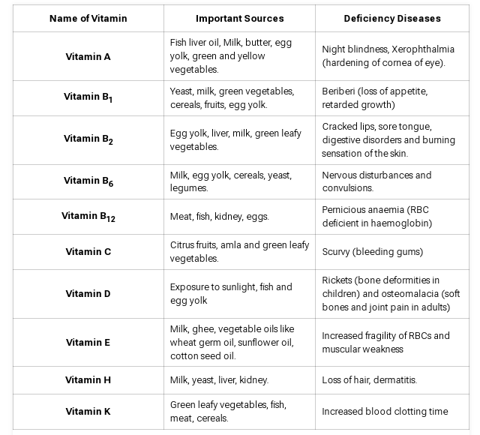

Functions:

Vitamin A
- Vitamin A helps in the development and maintenance of teeth and skeletal and soft tissues.
- It is also important for the maintenance of skin and the mucous membrane
- More importantly, the mucous membrane promotes good eyesight, specifically in low light.
- Beta-carotene, a form of vitamin A, protects cells from free radicals. This may reduce the risk of cancer.

Vitamin B
- Promotes cell health
- Important for the development of RBCs
- Vitamin B is required for healthy brain function
- It is also involved in the production of hormones and cholesterol
- It is required for proper muscle tone.

Vitamin C
- Important for the growth and repair of body tissues
- Helps to heal wounds more effectively
- Aids the absorption of iron
- Helpful for the maintenance of cartilage, teeth and bones
- Vitamin C is also an antioxidant, hence it aids in blocking some damage caused by free radicals

Vitamin D
- Required for mineral homeostasis
- Required for the formation of bones
- Required to maintain normal blood levels of phosphorus and calcium

Vitamin E
- It functions as a powerful antioxidant.
- Protects the cells from the effects of free-radicals
- Boosts immune system
- Required for fulfilling of various cellular functions

Vitamin K:
- Helps in blood clotting, bone health etc.

